TENDER
Sponsor Name
Prepare by
Date
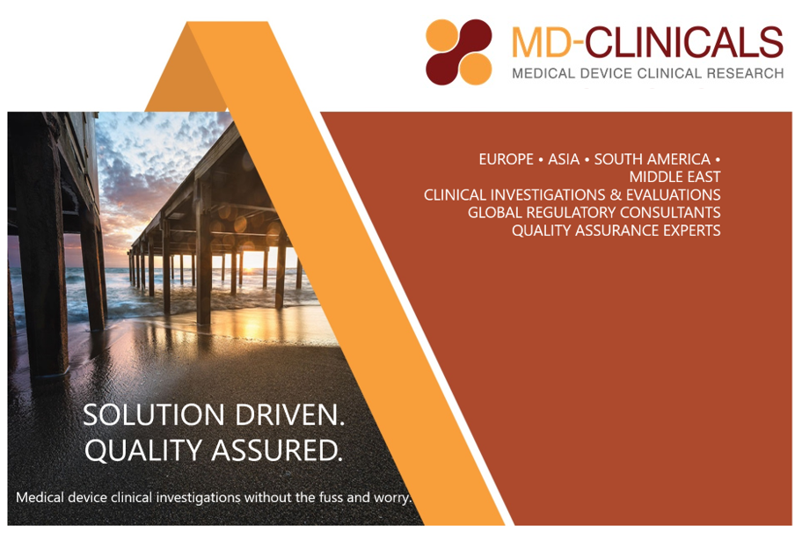

SUMMARY

To draft the initial tender, some assumptions outlined hereunder have been made. This tender is an initial draft, which, after clarifying the assumptions and the scope of work with [company name], will most likely need revision.

INTRODUCTION to MD-CLINICALS - MD-CLINICALS’s SERVICES
MD-Clinicals (“MD-Clinicals”) is 100% medical device focused and provider of international clinical research, regulatory and quality assurance services. Headquartered in Lausanne – Switzerland with branch offices in Beijing and Frankfurt and partner offices in the USA, Singapore, Jakarta, Brazil and Sydney, we have clinical research, regulatory and quality assurance staff serving the European, Asia Pacific, Chinese, North American, Middle East and South American territories.
Based on a strong management team with an outstanding track record in the medical device industry having served over 500 medical device companies worldwide in different areas of expertise, MD-CLINICALS is a unique provider of integrated services for medical device manufacturers and sub-contract manufacturers.
Our Mission:
A vision for excellence
MD-CLINICAL’s roadmap starts with our mission which is our company’s standard against which we measure our actions, performance and decisions.
- We serve the medical device industry worldwide, with excellence and high level of expertise and a personalised approach,
- We respect ethics and strive for scientific accuracy throughout all our actions and contribute to the protection of patient’s safety protection and well-being,
- We create value both for our employees and clients.

This unique focused specialization on medical devices including fast evolving regulatory territories assure our customers access to specialized regulatory/reimbursement and clinical expertise.
Clinical Services
Experienced medical device clinical project managers work hand in hand with customers to implement and manage their international clinical trials with excellence and efficiency. All clinical research associates have a paramedical/clinical background, are multilingual to cover an as wide territory as possible and all received extensive training to ensure compliance with ISO 14155, 21 CFR part 812, 50 and 56 as well as Chinese and Japanese GCP for medical devices and any additional national requirements for monitoring medical device clinical investigations in their designated territories. The paramedical/clinical background ensures that the monitors are at ease in understanding the handling of medical devices in a highly specialized environment and know how to navigate through the, often complex, management systems in the hospitals. Monitors are geographically based to ensure as much as possible the proximity with the investigation sites. Our quality system and server system is setup such that easy remote management of clinical investigations can be performed whether or not coupled with on-site monitoring.
Our strengths: keeping ahead of peers by integrating essential data points for successful reimbursement, while also supporting proof for usability alongside safety, performance and effectiveness.
MD-Clinicals’s medical device services covers all clinical and regulatory activities from strategic setup of a clinical program, taking into account all necessary regulatory and business requirements including reimbursement/health economics, all the way to the final report ready for submissions. Selection of investigations sites, writing of clinical investigation plans/protocols, designing case report forms, ethics committee/IRB submissions and Competent Authority notifications at national level in the designated countries, MD-Clinicals offers state of the art data management services using electronic data capturing systems adapted to the needs of our clients. We work with biostatisticians who understand medical devices and truly support the regulatory strategy of our customers in a worldwide market strategy.
Through our sister company WMDO, we ensure ongoing training of all our staff and access to excellent experts who can support our clients throughout the product lifecycle.
WMDO also ensures an up-to-date ongoing training of our staff as well as certified online training of Investigators, study staff in a cost effective manner.
Because we know that time to market is as precious as cost efficient services, we provide our clients with periodic budget status reports integrated in the project reports.
Regulatory/Medical Writing services
Our expert team of medical writers assists clients throughout the world with state of the art clinical evaluation processes including efficient literature reviews and analyses. We take it all to the end ready to submit with review of your critical documents such as instructions for use, writing of post market surveillance reports and plan your post market clinical follow up activities.
MD-CLINICALS’ team of experts throughout the world work closely together to provide the medical device industry with integrated regulatory strategies, and quality assurance solutions improving business solutions while ensuring regulatory compliance. Either direct or through validated partnership we can offer product registration services throughout Asia-Pacific, South American and Middle Eastern countries including license holding in dedicated territories.
Reimbursement/Health Economics
No device can be sold successfully on the market without the right reimbursement or health economics strategy. Integrating this strategy in the pre-market phase in the clinical and regulatory strategy is essential. MD-CLINICALS specializes in ensuring our clients get to the right reimbursement data and whenever possible include such requirements in the pre-market clinical investigations.

ORGANIZATION
A senior project manager or senior expert will be appointed to work as a central key contact person for ______________at MD-CLINICALS.

STANDARDS
For Clinical Trials, MD-CLINICALS assumes that the ISO 14155, and FDA CFR 21 part 812, 50 and 56 will be followed and in addition local requirements such as NMPA, PMDA clinical investigation requirements.. Our quality system is setup to ensure compliance with all GCP requirements in the territories we operate. All monitoring operations will be performed in accordance with MD-CLINICALS SOPs unless otherwise requested by the Sponsor.

SCOPE OF WORK

Documents and data base

Documents to write | Sponsor |  | MD-CLINICALS
 | Write | Review | Write | Review
Writing of a clinical investigation plan

Sample size calculations and justification
Development of a CRF

Development of Investigator Brochure
Writing of master informed consent
Translations of documents
Adaptation of Informed consent to local requirements
Investigator agreements (can be based on MDC templates)
Develop EDC system
- Naming convention to be approved by biostatistician if at Sponsor)
- Data base outlined
- Data management plan
User Acceptance Testing EDC system
DSMB charter
CEC charter
Ethics committee submissions (XX submissions)
Competent authority notification (X countries)
Write project guidelines (complete safety, data management and monitoring guidelines)
Initiation visit report
Monitoring visit reports
Progress reports during study (clinical project manager)
Write CEC meeting reports
Write DSMB meeting reports
Close down visit report
Data management report (# of reports X)
Statistical analysis plan
Statistical analysis report (# of reports X)
Clinical investigation report (# of reports X)

Clinical Investigation tasks
Tasks to perform | Sponsor | MD-CLINICALS
Site selection and visit (remote : ☐ onsite: ☐)
Negotiate investigator funding
DSMB selection |  | Make suggestions
CEC selection |  | Make suggestions
Setup e-Trial Master Files
Setup e-Investigator files
Progress reports during setup (clinical project management)
Client meetings during setup (weekly)
Maintain trial master file
Device shipment to sites
Initiation visit (1 visit per site) (remote : ☐ onsite: ☐)
Monitoring visits (#/sit: XX visits per site)
(remote : ☐ onsite: ☐)
Ongoing monitoring administration (1x/month)
- Contacts with sites
- Review of safety
- Check data base for compliance
- Check e-investigator file for compliance
Device accountability
- Ongoing during monitoring visits
- Reordering of investigational devices
- Further shipments of investigational devices
Client meetings during study (monthly)
Project budget tracking
Data management
- Data cleaning (after each monitoring visit)
- Data management administration – support to users
- Data base freeze
Safety reporting
- Perform ongoing pre-market study reporting to EC and CA (MDCG 2020-10/1 and 2)
- ensure EC reporting by investigator
- Periodic reporting to the CA (quarterly or annually according to CA requirements)
Ongoing CEC management
- CEC meetings every XX- SAEs
Ongoing DSMB management XX meetings
Close down visit (remote : ☐ onsite: ☐)
Conduct statistical analysis (# of analyses X )
Clinical report Sign off by investigators
Notify study closure to EC
Notify study closure to CA |  | x

Auditing
- To be discussed

MEDICAL WRITING SERVICES
Not yet quoted for nor the regulatory support in the CE-mark process.

Gap analysis

The gap analysis of your existing documents is included in the services before we start with the writing of your clinical evaluation documents. The gap analysis will not only be done compared to the regulatory requirements but also to identify possible inconsistencies within your existing documents starting with the instructions for use and identification of claims (performance, safety and clinical benefits) as well as intended use vs indications for use.

Clinical Evaluation Plan (CEP)
A clinical evaluation plan is the first step in the clinical evaluation process and includes defining your claims within the intended use, bench mark your device vs standard of care (SOTA), develop rational for equivalence if appropriate, identify existing data (pre-clinical and clinical), setup a clinical development plan, develop a literature search protocol and an appraisal plan.

Clinical Evaluation Report (CER)
The CER services include the running of literature reviews for both SOTA and device under evaluation. We are using Distiller to automize partly this process making literature review more efficient and accurate. For the evaluation report we need your pre-clinical data including usability, sterilization and other safety assessments reports. We also need the clinical reports of any of the clinical investigations you conducted. Should your data be generated outside the EU, then a foreign data justification may be needed for which we will run extra literature reviews to justify how your data apply from a ethnic, physiological, standard of care point of view to the EU populations.

Post marker clinical follow up (PMCF) plan, PMCF reports, PMS plan, Periodic safety update report (PSUR)
Compliant to the EU regulations, Notified bodies will want to see the PMCF plan and PMS plans which must be aligned with the CER conclusions. When further in the process, PMCF reports and PSUR will be required which we can prepare for you based on your results of post market activities.

Summary of Safety and Clinical Performance (SSCP)
We will produce this document based on your existing documents. This document must be written to inform the users. For your device, the document is also needed for patients which means the version of the users will be adapted to lay-term readers.

BUDGET

Clinical Services

Data base usage
Study | Criteria | Pricing
 | XXmonths of usage  XX unique pages  Randomization Yes ☐ No ☐  X sites  XX treated patients | €

Pass-through costs estimation

Item | Unit pricing | Estimated cost
EC submissions (EC X )
CA notifications (# of countries X)
Translations (languages X)
Clinical investigation insurance
Investigator fees (# patients X)
TOTAL

GENERAL CONDITIONS
Based upon the above scope of work, the cost estimate is outlined thereunder. Travel costs are not included, nor are communication and printing costs, which will be billed at cost with justifications attached.
All prices are given in Euros and do not include VAT (not applicable to Sponsors outside Switzerland).

All costs will be billed based upon the time sheets provided by the monitors and other collaborators.
A startup cost of € XXXXXXX is invoiced when the agreement to cover initial expenses is signed. This startup cost will be credited upon completion of the project.
The Tender estimates are based upon the received information from the Sponsor. MD-CLINICALS reserves the right to revise the workload if the scope of the work has not been accurately defined or if the quality of the essential documents need further clarifications prior to implementation.
No new tasks (not specified in the Tender) or excesses in budgets shall be initiated by MD-CLINICALS without prior approval from Sponsor.
This Tender is valid for the duration of 30 days.
The project begins with the signing of a Master Agreement outlining the general conditions and a Project Agreement. Both agreements are construed under the Swiss law.

